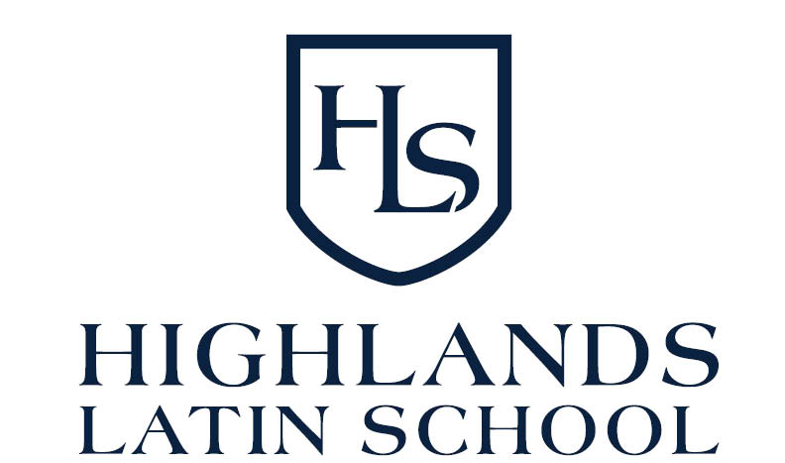

2020-2021

Dear Parents,

Welcome to the 2020-2021 school year! It has been exciting and humbling for me to watch this community take shape, and I am so looking forward to spending a year together. This year, in partnership with you and guided by the Gospel, we will work hard to educate each student to the highest standards of the classical tradition so that they may grow in knowledge, wisdom, and the love of Our Lord.

Docere, Delectare, Movere
To teach, to delight, to move…

Dawn Holmberg
Highlands Latin School Director

HLS Director: Mrs. Dawn Holmberg 970-282-3814 :: dawn@highlandslatin.org

Instructors

Mr. Doug Post doug.post@comcast.net
Mrs. Katie Strader kstrader11@yahoo.com
Mr. Eddie Gomez
Mr. Craig Wilson
Mrs. Amanda Wilson

Daily Logistics

Doors will open at 7:45am, and classes will begin promptly at 8:00am. Doors to the church will be locked during class time so if you arrive late you will need to notify the director or instructor to open the doors for you when you arrive.
Classes end at 2:45pm. Please pick up your students promptly as we do not have after school care.
Please have your student bring all necessary materials to school (writing utensils, books, notebook, water bottle, lunch, and proper outer wear for outside recess.

Dress Code

Students are to wear a solid color (navy, white or burgundy) shirt with a collar. Shirts may be polo style, or button-up. Solid color slacks or skirts (grey or navy) no shorter than 1” above the knee are to be worn on bottom. Please see Dress Code agreement in application packet for more details.

Please provide your child with appropriate outerwear. Unless it is extremely cold, wet or icy we will be spending a portion of break time outside.

Inclement Weather

HLS will follow the weather cancellation policy of the Thompson Valley School District. Check with www.thompsonschools.org. In addition, HLS will send out an email if classes are be canceled by 6am. No make-up classes will be cancelled.

Sick Child Policy

Please exercise discretion and caution when it comes to sick children.
Please do not bring your child(ren) if any of the following are present:
- Vomiting / diarrhea within the past 24 hours
- Fever within 24 hours
- Rash or unusual spots on his/her skin
- Mucous, any color than clear, running from his/her nose or eyes
- Excessive coughing, sneezing or lethargic
- Under current care with a physician in treating any illness

If any of these symptoms occur within your child(ren), be courteous to everyone and please keep child(ren) home. Please see COVID-19 Protocol form for specific 2020-2021 details.
Please contact me if you will NOT be attending for the day so we can prepare accordingly.

Allergies

We do have students with food allergies, but at this time there are not any items which are not permitted on campus. However, please have your children wash their hands and eating area after consuming any nut products. Washing hands and cleaning up after ourselves is always a good choice!

Please bring a lunch for your children along with a water bottle. All children’s belongings should be labelled with their first and last name.

COVID 19 Protocol

Operating Procedures:
- All areas outside of the classroom space, bathrooms and lunch area are to be off limits in First Congregational Church.
- Bathroom usage is to be limited to one person at a time.
- The Kitchen is off limits to students. Should a student require the use of the refrigerator or microwave, a designated HLS staff member will assist them.
- There will be no sharing of school supplies or personal belongings.
- As per state mandate, all individuals over the age of 10 are required to wear a mask in public unless you fall in the exemptions listed in the mandate. (Please contact HLS Director for further details/clarification)

Illness Policy
- Students and staff showing any signs of illness (cough, fever, runny nose…) should stay home. Students or staff presenting with any signs of illness throughout the school day will be asked to leave. Parents will be notified so students can be picked up as soon as possible.
- In the event that a student or staff member tests positive for COVID-19, they will self-quarantine for 14 days. The Church, and all HLS Families and staff will be notified of the possible exposure to COVID-19.
- If two or more HLS families or staff members test positive for COVID-19, the whole school may be shut down for 14 days.
School Closure
- As stated above, should two or more HLS families or staff members test positive for COVID-19, the school may close for 14 days. All learning would be transferred to our remote system.

Please call Dawn Holmberg at (970)282-3814 if you have any questions, need clarification, or need to report a positive test result.

